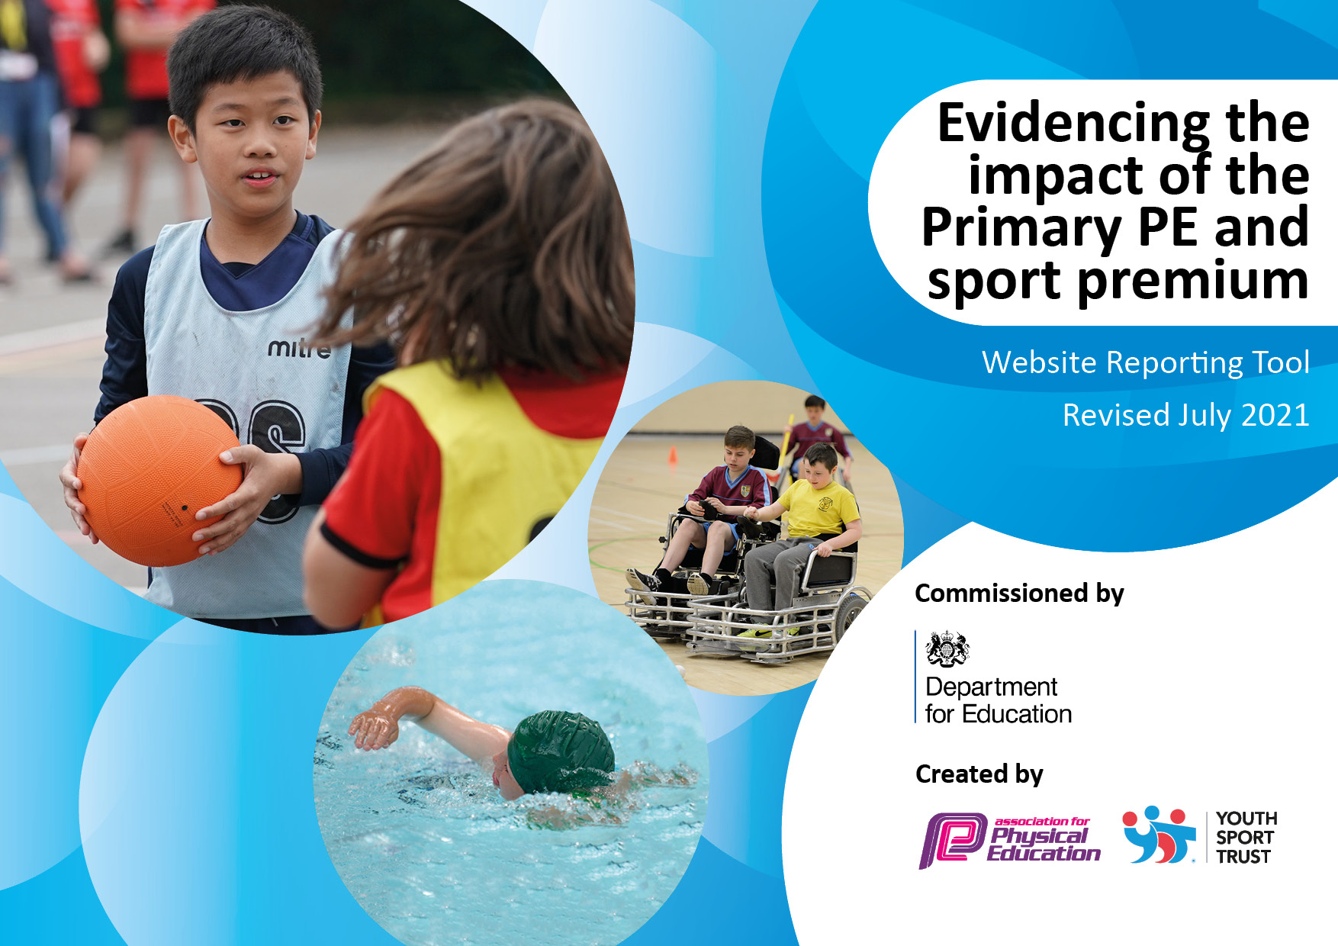
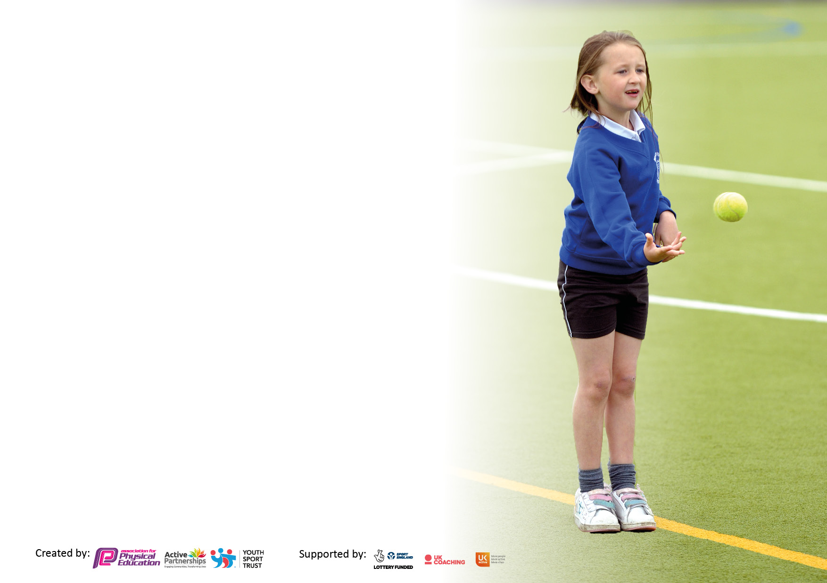

It is important that your grant is used effectively and based on school need. The Education Inspection Framework makes clear there will be a focus on ‘whether leaders and those responsible for governors all understand their respective roles and perform these in a way that enhances the effectiveness of the school’.

Under the Quality of Education Ofsted inspectors consider:
Intent - Curriculum design, coverage and appropriateness
Implementation - Curriculum delivery, Teaching (pedagogy) and Assessment
Impact - Attainment and progress

To assist schools with common transferable language this template has been developed to utilise the same three headings which should make your plans easily transferable between working documents.

Schools must use the funding to make additional and sustainable improvements to the quality of Physical Education, School Sport and Physical Activity (PESSPA) they offer. This means that you should use the Primary PE and sport premium to:

- Develop or add to the PESSPA activities that your school already offer
- Build capacity and capability within the school to ensure that improvements made now will benefit pupils joining the school in future years
- The Primary PE and sport premium should not be used to fund capital spend projects; the school’s budget should fund these.

Pleasevisitgov.ukfortherevisedDfEguidanceincludingthe5keyindicatorsacrosswhichschoolsshoulddemonstrate animprovement.Thisdocumentwillhelpyoutoreviewyourprovisionandtoreportyourspend.DfEencouragesschools to use this template as an effective way of meeting the reporting requirements of the Primary PE and sport premium.

We recommend you start by reflecting on the impact of current provision and reviewing the previous spend.

Schools are required to publish details of how they spend this funding, including any under-spend from 2019/2020, as well as on the impact it has on pupils’ PE and sport participation and attainment. All funding must be spent by 31st July 2022.

We recommend regularly updating the table and publishing it on your website throughout the year. This evidences your ongoing self-evaluation of how you are using the funding to secure maximum, sustainable impact. Final copy must be posted on your website by the end of the academic year and no later than the 31st July 2021. To see an example of how to complete the table please click HERE.
Created by: Supported by:

Details with regard to funding
Please complete the table below.

Total amount carried over from 2020/21 | £ 0
Total amount allocated for 2021/22 | £ 11,655
How much (if any) do you intend to carry over from this total fund into 2022/23? | £ 11,655
Total amount allocated for 2022/23 | £ 17, 750
Total amount of funding for 2022/23. To be spent and reported on by 31st July 2023. | £ 17, 750
Swimming Data
Please report on your Swimming Data below.

Meeting national curriculum requirements for swimming and water safety.

N.B. Complete this section to your best ability. For example you might have practised safe self-rescue techniques on dry land which you can then transfer to the pool when school swimming restarts.
Due to exceptional circumstances priority should be given to ensuring that pupils can perform safe self rescue even if they do not fully meet the first two requirements of the NC programme of study
What percentage of your current Year 6 cohort swim competently, confidently and proficiently over a distance of at least 25 metres?  N.B. Even though your pupils may swim in another year please report on their attainment on leaving primary school at the end of the summer term 2023.  Please see note above | 9%
What percentage of your current Year 6 cohort use a range of strokes effectively [for example, front crawl, backstroke and breaststroke]?  Please see note above | 6%
What percentage of your current Year 6 cohort perform safe self-rescue in different water-based situations? | 9%
Schools can choose to use the Primary PE and sport premium to provide additional provision for swimming but this must be for activity over and above the national curriculum requirements. Have you used it in this way? | Yes – additional sessions for Y6 cohort due to impact of the pandemic and high needs of low level skill

Action Plan and Budget Tracking
Capture your intended annual spend against the 5 key indicators. Clarify the success criteria and evidence of impact that you intend to measure to evaluate for pupils today and for the future.

Academic Year: 2022/2023 | Total fund allocated: | Date Updated:
Key indicator 1: The engagement of all pupils in regular physical activity – Chief Medical Officers guidelines recommend that primary school pupils undertake at least 30 minutes of physical activity a day in school |  |  |  | Percentage of total allocation:
 |  |  |  | 49%
Intent | Implementation |  | Impact
Your school focus should be clear what you want the pupils to know and be able to do and about  what they need to learn and to  consolidate through practice: | Make sure your actions to achieve are linked to your intentions: | Funding allocated: | Evidence of impact: what do pupils now know and what can they now do? What has changed?: | Sustainability and suggested next steps:
- To continue to implement strategies that strive to increase physical activities for our pupils during the school day including lessons outside of PE.  - To encourage Healthy lifestyle through purchase of fruit for KS2 | - After school clubs to continue to be organised for every term with the opportunity for all pupils to access clubs.  - SEND children to continue to attend SMILE competitions and festivals.  - Implement tasks and routines during the school day to increase physical activity – lunchtime club with PE activities | £3500 for an adult to lead an after school club for 35 weeks  £400 cost of transport to SMILE events  Other resources to support physical activities outside PE lessons - £5000  KS2 FRUIT - £4,878 | - More children are achieving the CMO recommendation of at least 30 minutes of physical activity during the school day  - There are greater opportunities in place for pupils to be physically active throughout the school day, outside of PE lessons | - Review of tasks and routines to ensure that increased physical activity becomes embedded in the school day  - Continue to implement rainbow warriors, lunchtime supervisors and playground buddies to support provision throughout the school day  - Site manager to ensure that walk the mile is safe and can go ahead.
Key indicator 2: The profile of PESSPA being raised across the school as a tool for whole school improvement |  |  |  | Percentage of total allocation:
 |  |  |  | 1.1%
Intent | Implementation |  | Impact
Your school focus should be clear what you want the pupils to know and be able to do and about  what they need to learn and to  consolidate through practice: | Make sure your actions to achieve are linked to your intentions: | Funding allocated: | Evidence of impact: what do pupils now know and what can they now do? What has changed?: | Sustainability and suggested next steps:
- To implement the ABC rainbow Warrior programme to raise the profile of PE, physical activity and school sport | - School learning mentor to be link teacher to liaise with other staff and stakeholders  - School learning mentor to attend training and disseminate information to children | £200 for resources to support the programme | - Increased levels of physical activity at break and lunchtimes  - Rainbow warriors invited to share success at local authority PE conference – viewed as a model of good practice | - Rainbow warriors to be further trained to ensure that this approach continues to be embedded  - Training to be cascaded throughout school to ensure a long term impact

Key indicator 3: Increased confidence, knowledge and skills of all staff in teaching PE and sport |  |  |  | Percentage of total allocation:
 |  |  |  | 34.5%
Intent | Implementation |  | Impact
Your school focus should be clear | Make sure your actions to | Funding | Evidence of impact: what do | Sustainability and suggested
what you want the pupils to know | achieve are linked to your | allocated: | pupils now know and what | next steps:
and be able to do and about | intentions: |  | can they now do? What has
what they need to learn and to |  |  | changed?:
consolidate through practice:
- To continue to provide ongoing professional development for teaching staff in all areas of the PE curriculum in order to continually improve provision for the PE curriculum taught across school  - Subject leader time  - Subject leader CPD | - Weekly CPD provided through SLA with Premier Sports for 1 day per week.  - Children experience a broad and balanced PE curriculum with a continued focus on SEND children.  - Curriculum overview agreed with VP/PE leader and sports provider ensuring knowledge and skills are developed  - Ongoing programme of support from Premier Sports and Staff. | £6125  Staffing / CPD / management time for subject leader | - Increase in teacher knowledge and confidence when delivering sport specific skills in line with the curriculum  - An increase in pupil progress in all areas of the PE curriculum  - Teachers are able to use knowledge of the PE curriculum to accurately assess children’s attainment and progress in PE under the guidance of the specialist coach. This is then added to the school’s assessment tool (Arbor). | - Staff highly skilled in all areas of the PE curriculum and can lead on all areas of the curriculum under support from specialist coach.
Key indicator 4: Broader experience of a range of sports and activities offered to all pupils |  |  |  | Percentage of total allocation:
 |  |  |  | 5.6%
Intent | Implementation |  | Impact
Your school focus should be clear | Make sure your actions to | Funding | Evidence of impact: what do | Sustainability and suggested
what you want the pupils to know | achieve are linked to your | allocated: | pupils now know and what | next steps:
and be able to do and about | intentions: |  | can they now do? What has
what they need to learn and to |  |  | changed?:
consolidate through practice:
- Continue to provide a wide range of competitive and non-competitive sports clubs to increase the opportunities for the children to participate in physical activities | - Children surveyed for the sports that they wish to be the focus of after school clubs. A long term plan for after school clubs then created by SLT and learning mentor  - Increase the number of opportunities available to pupils to participate in extra-curricular activities  - Identify where local sports clubs can support with increasing opportunities for our children to engage in physical activity | £1000 resources for after school clubs and PE opportunities during break times | - School able to accurately identify the number of children accessing our extra-curricular clubs offer  - All children, including SEND and those most disadvantaged and LAC, are provided with opportunities to take part in a range of physical activities throughout the school day and after school. | - Strive to continue to increase the number of pupils accessing physical activity throughout the school day  - Increase the number of children accessing community sport

Key indicator 5: Increased participation in competitive sport |  |  |  | Percentage of total allocation:
 |  |  |  | 13.6%
Intent | Implementation |  | Impact
Your school focus should be clear | Make sure your actions to | Funding | Evidence of impact: what do | Sustainability and suggested
what you want the pupils to know | achieve are linked to your | allocated: | pupils now know and what | next steps:
and be able to do and about | intentions: |  | can they now do? What has
what they need to learn and to |  |  | changed?:
consolidate through practice:
- All children to participate in competitive sporting activities in a wider variety of sports  - Ensure children are experiencing a wide range of competitive sport to develop an understanding of the importance of competition in sport | - School registered for a programme of competitions throughout the school year  - Sport educator and teachers to promote opportunities for competitive sport through PE lessons and sharing the importance of competition  - Sport educator to support school by preparing pupils to participate | Cost of transportation  £2,414 | - Increased opportunities for pupils to participate in school sport in the following sports:  Football, Basketball, Cricket, Netball, Tag Rugby  - MAC sports day event to take place at Hagley High School  - Coaches from Premier Sport supported school to lead on sports day | - Competitive sport with other schools and intra competitions to continue throughout the next year

Signed off by
Head Teacher: | C. Hinton
Date: | 21/07/2023
Subject Leader: | L. Reaney
Date: | 20/07/2023
Governor: | S. Godber
Date: | 25/7/2023

